**Note:** Create the tables as indicated in Read Me for Search Help Demos.doc.

Proceed with the below steps only after that.

1. Create an Elementary search help in SE11.

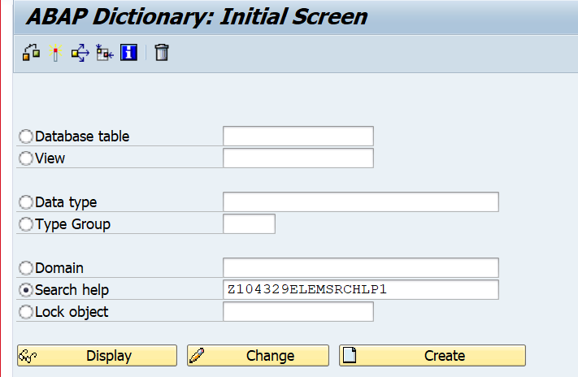

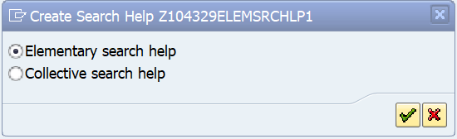

1. Enter the table name as shown below. .

Enter the search help parameters. After entering each search help parameter, the data elements are displayed. There is NO need to enter the data elements.

Enter the LPos and SPos as shown below.

Select the IMP EXP as shown below.

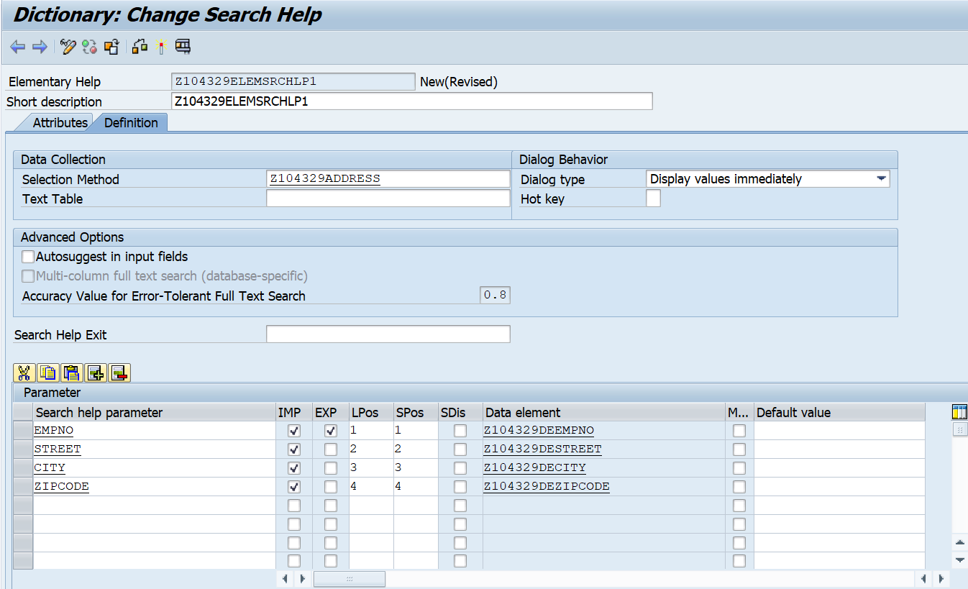

Import parameters are seen in hit list. Export parameters are visible on screen.

1. Test the search help.

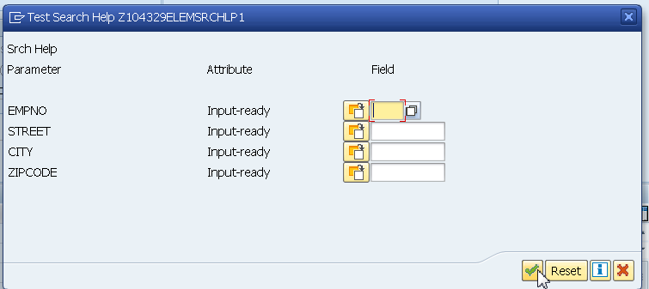

1. Note the Import parameters.

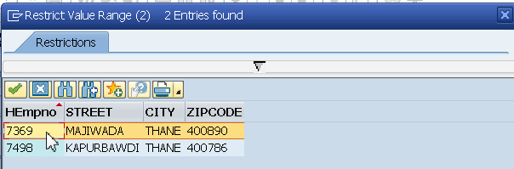

1. Note the Export Parameter. Empno is Imp and Exp parameter. Hence seen here.

Street, city and zip code are just export parameters.

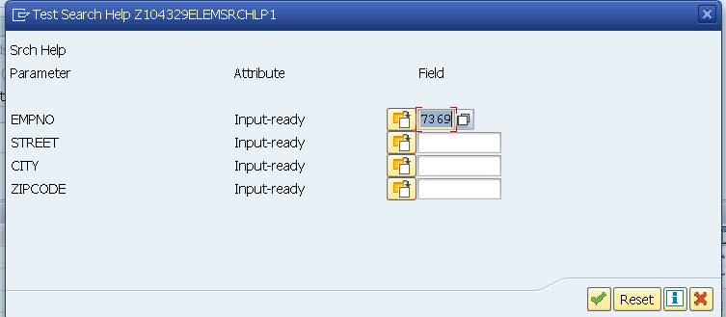

Testing of Elementary search is complete.

Go to SE11. New session.

1. Attach the elementary search help to the DB table. (Another DB table)

In this case search help is attached to Empno of the Emp table.

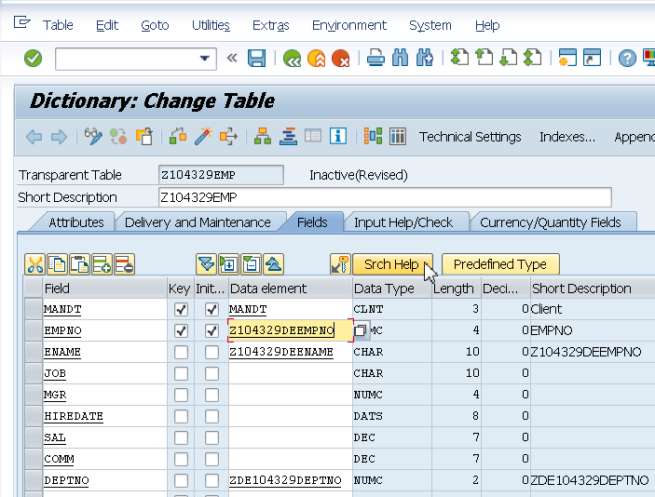

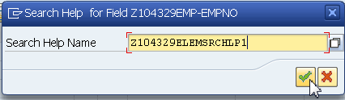

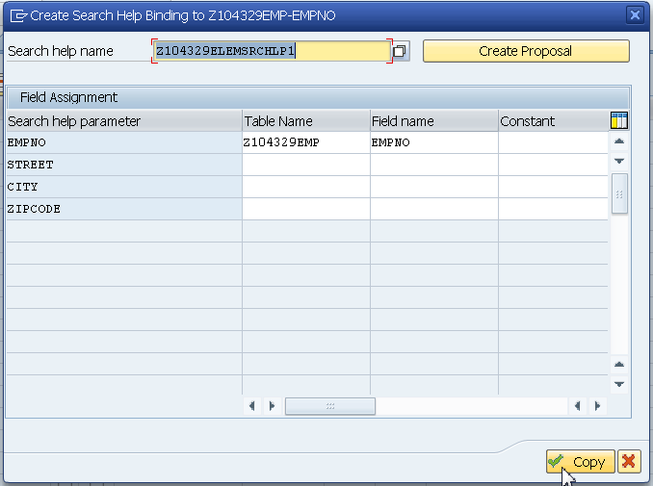

1. Create entries in the Emp DB table.(Utilities-Table contents-Create entries)

Observe search help while adding records in the Empno field of the Emp table.

